ASE Lab 4 Report

Class ID:21

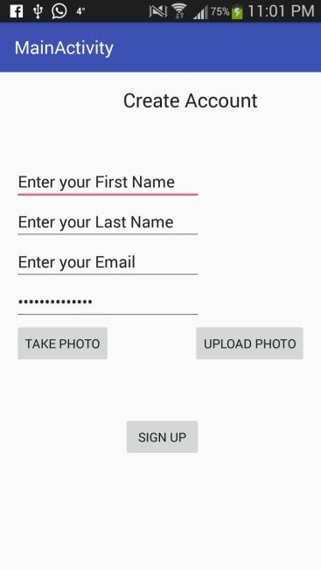 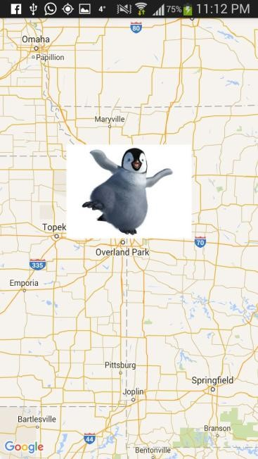

UPLOAD PHOTO-> From GALLERY

Ref: ASE Lab 4 Turtoial Source Code, developer.android.com